Experiment: 7

Analog Beamforming Analysis Using MATLAB

Aim
To analyze the performance of analog beamforming by studying beamforming gain, beam width,
and main lobe direction using MATLAB.
Objectives
- To analyze the beamforming gain achieved by varying the number of antenna elements in an analog beamforming system using MATLAB.
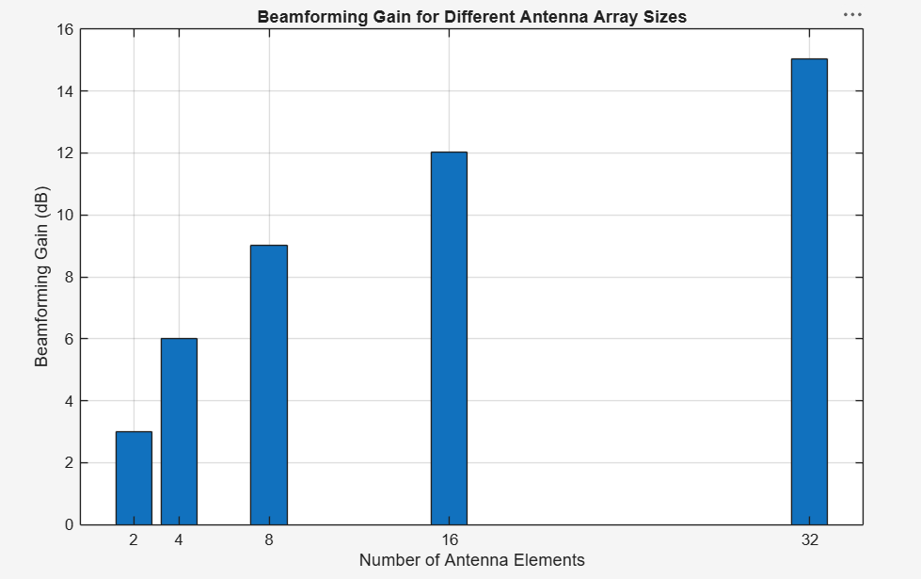
- To compare the beam width of an antenna array for different beamforming configurations using MATLAB.
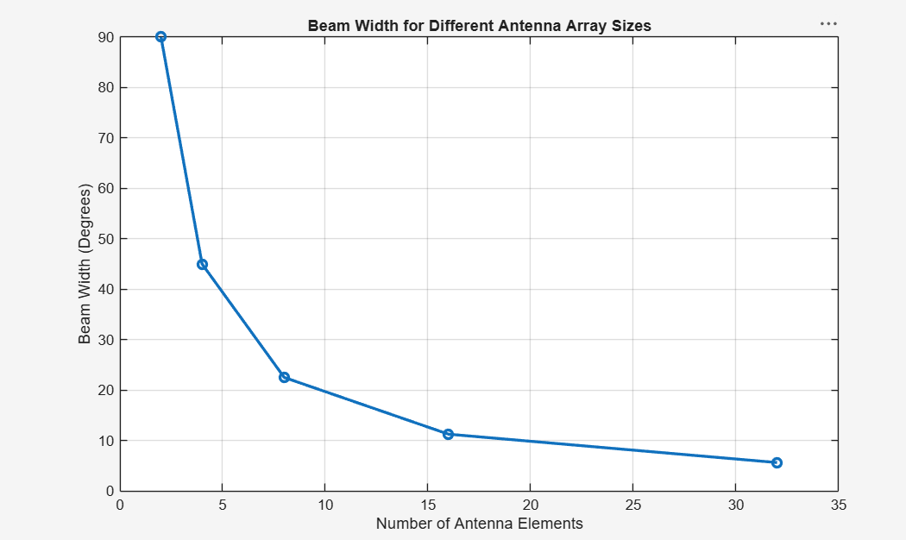
- To analyze the main lobe direction by steering the antenna array beam to different angles using MATLAB.
